Service Catalog Setup
Creating Policy
- From AWS console login, go to ‘Identity and Access Management’ screen.
- From the left navigation panel choose ‘Policies’
- Click on “Create Policy”.
- Select “Create Your Policy”.
- Switch to “Json” tab. Replace the existing template script with script given below. This script will create IAM policy with MFA restrictions.
{
"Version": "2012-10-17",
"Statement": [
{
"Effect": "Allow",
"Action": [

# Add extra permissions for workflow execution here

"s3:Get*",
"servicecatalog:*",
"cloudformation:*"
],
"Resource": "*",
"Condition": {
"Bool": {
"aws:MultiFactorAuthPresent": "true"
}
}
}
]
}
- Click on “Review Policy”.
- Provide some name and description to the policy and click on “Create Policy”.

Creating Group & Attaching Policy

1. From the left navigation panel choose ‘Groups’
2. Click on “Create New Group”.
3. Provide Name to Group.
4. Now, attach the policy we created in the previous process.

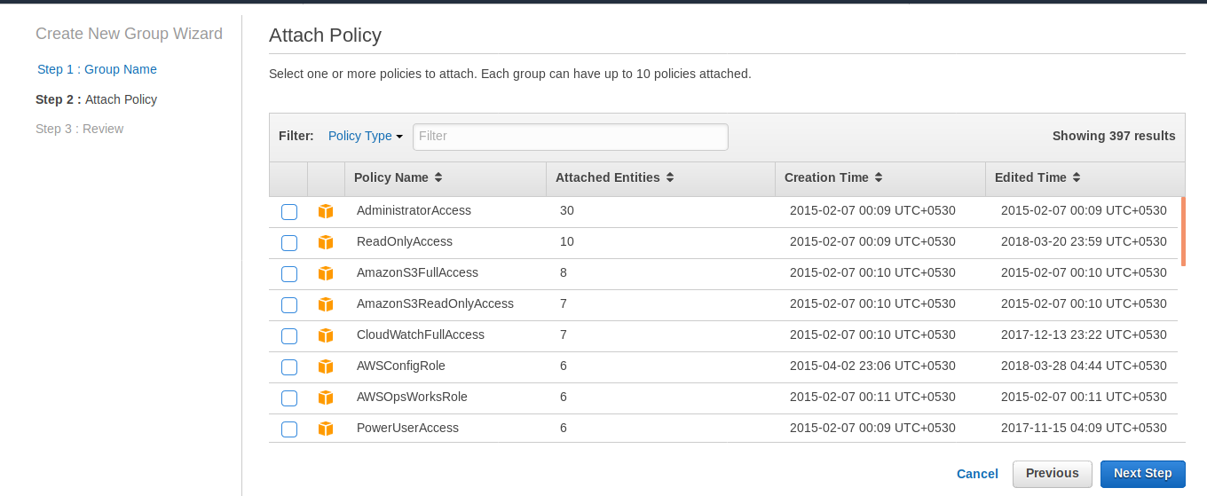
5. Click on “Create Group”.

Creating User and Adding it to Group

- From left navigation Panel, Select “Users”.
- Click on “Add User”.
- Provide username. In the access type, Only choose ‘Programmatic Access’.
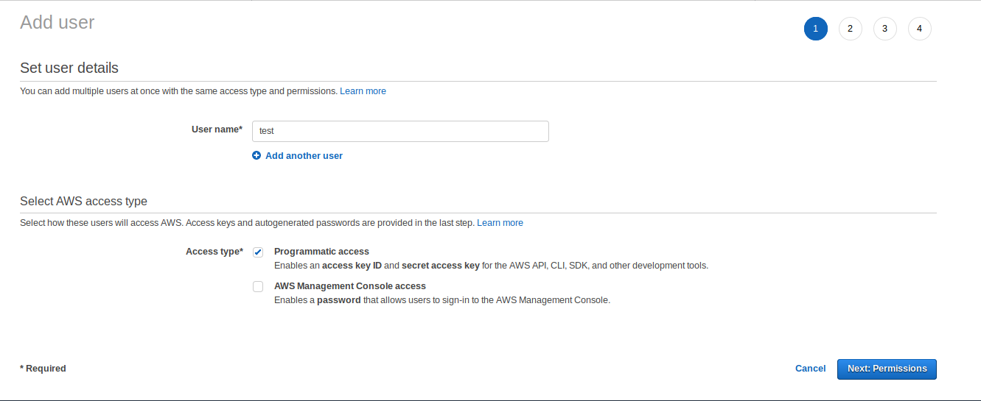
- On the Next Screen, Add user to the group created in last process.
- On the last step, when user is created save the access and secret keys of the user.
- Now , select the user created in last step and switch to “Security Advisor” tab.
- Click on “Assigned MFA device”.
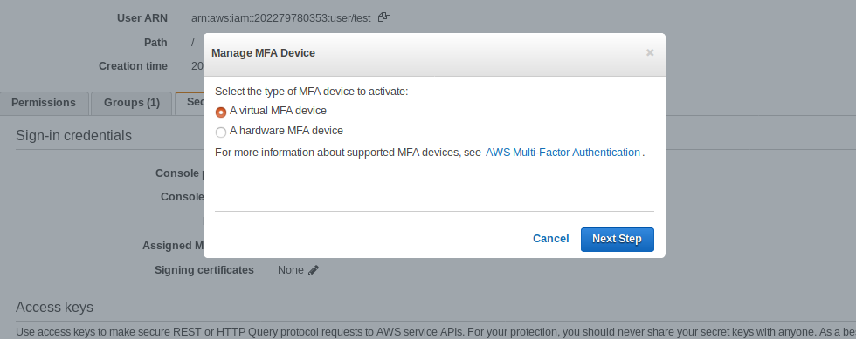
- Choose “Virtual MFA device”.
- In the next Screen, QR-Code image pops-up, scans it with your smartphone(Install MFA applications).

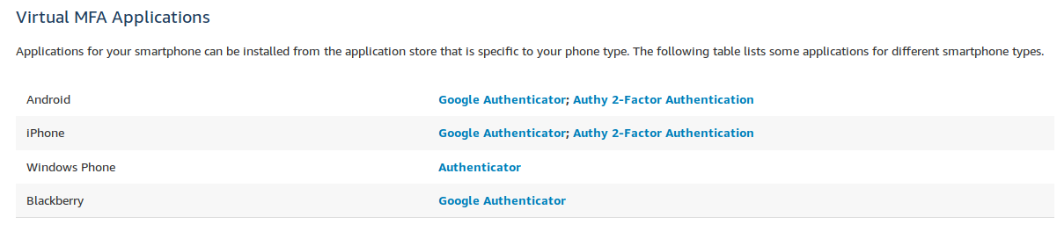
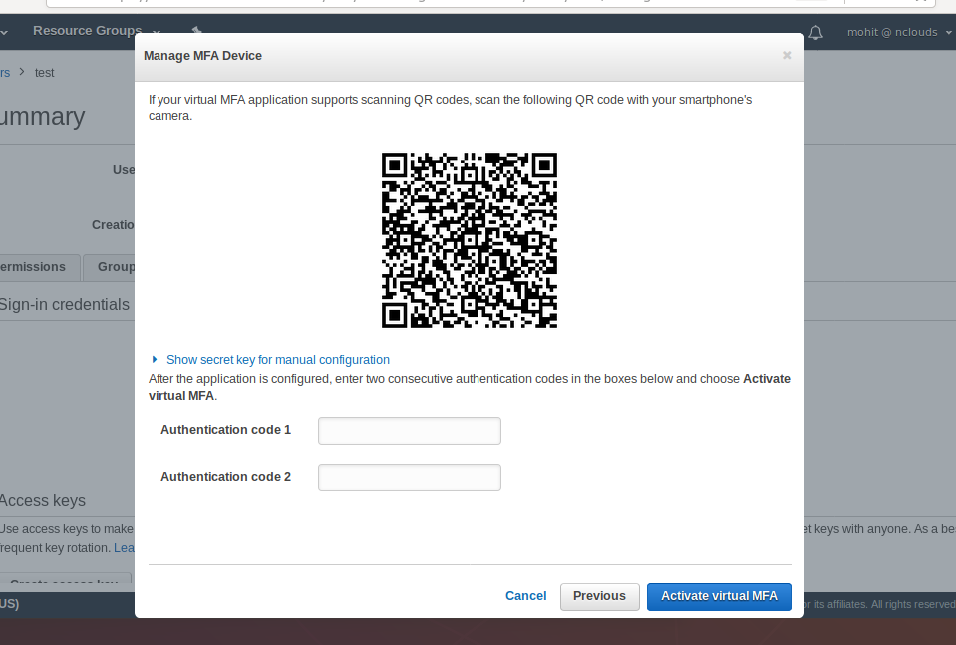
- Type in the 2 consecutive Authentication codes in the Authentication Code boxes.
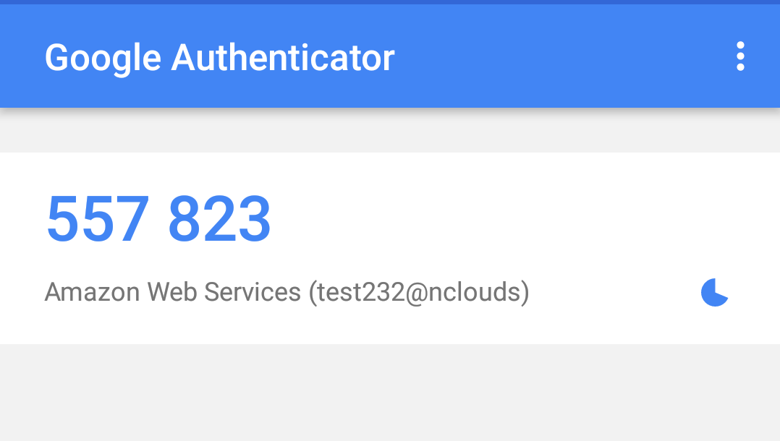
- After enabling MFA save the ARN of the MFA Device and click on “Activate Virtual MFA”

Note: For workflow execution to work you have to create a Portfolio in AWS in the Service Catalog section.
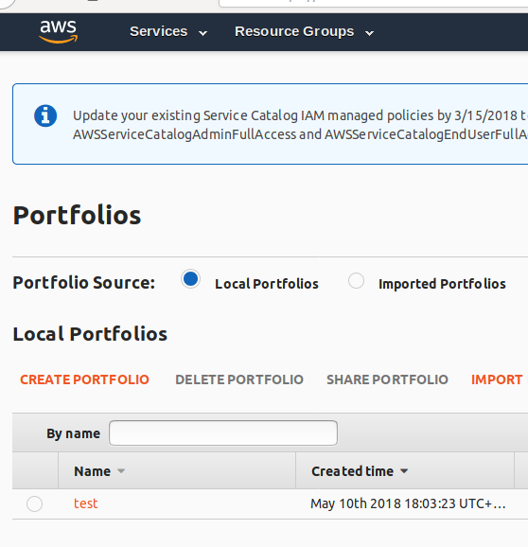
- Click the portfolio and expand the Users, groups and roles section and add the group created before.
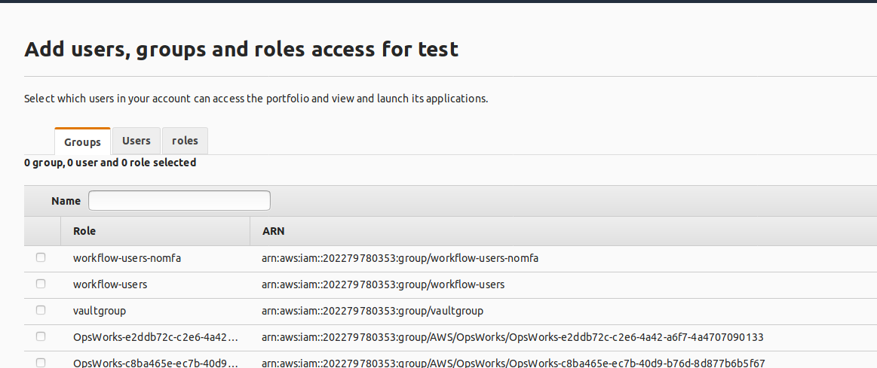

In nOps:
- Go to Workflows > Available Workflows
- Click on credential settings
- Input access key, secret key and MFA device ARN.
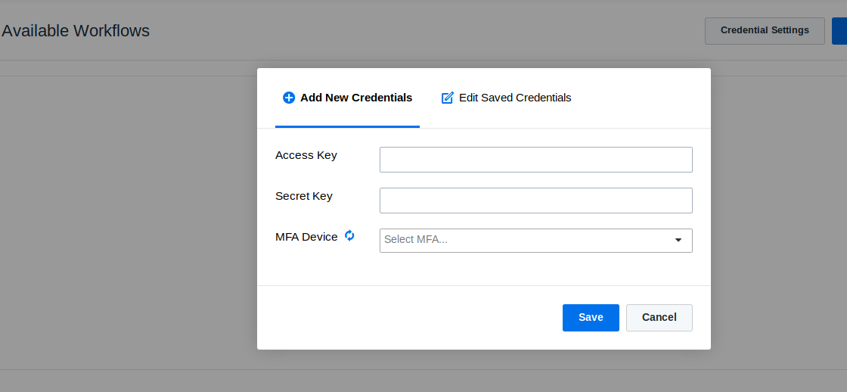

Creating a product:
Before creating a product you will need:
- A CloudFormation template of the product you want to create
- An IAM policy with the necessary permissions to deploy the product. (See page 1 for policy example)
- On the AWS Console go to service catalog section and select Portfolio List:

- On the AWS Console go to service catalog section and select Product List:
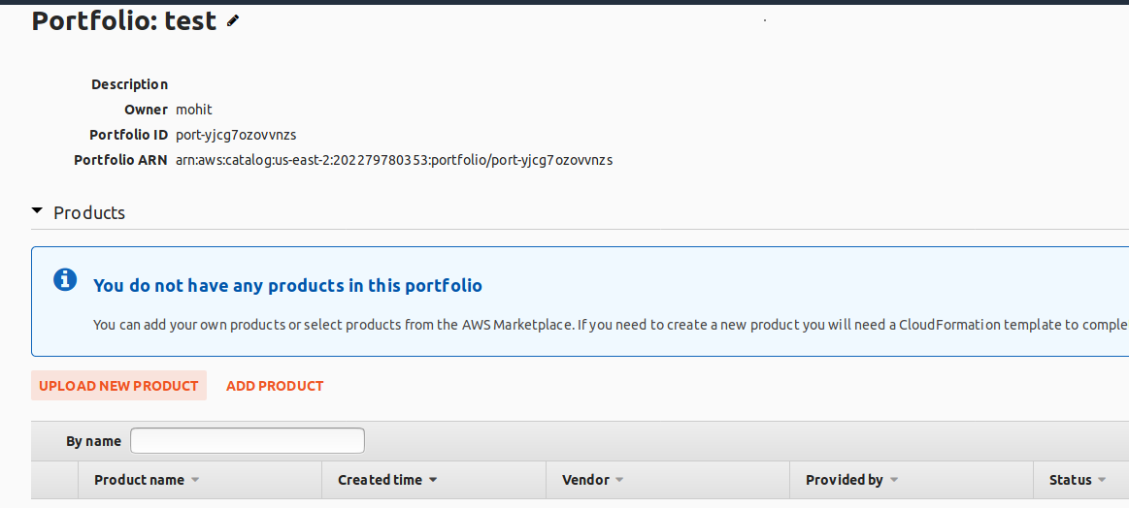

- Click on Upload new product button and fill in the required forms. You will be prompted for product details and a CloudFormation template.
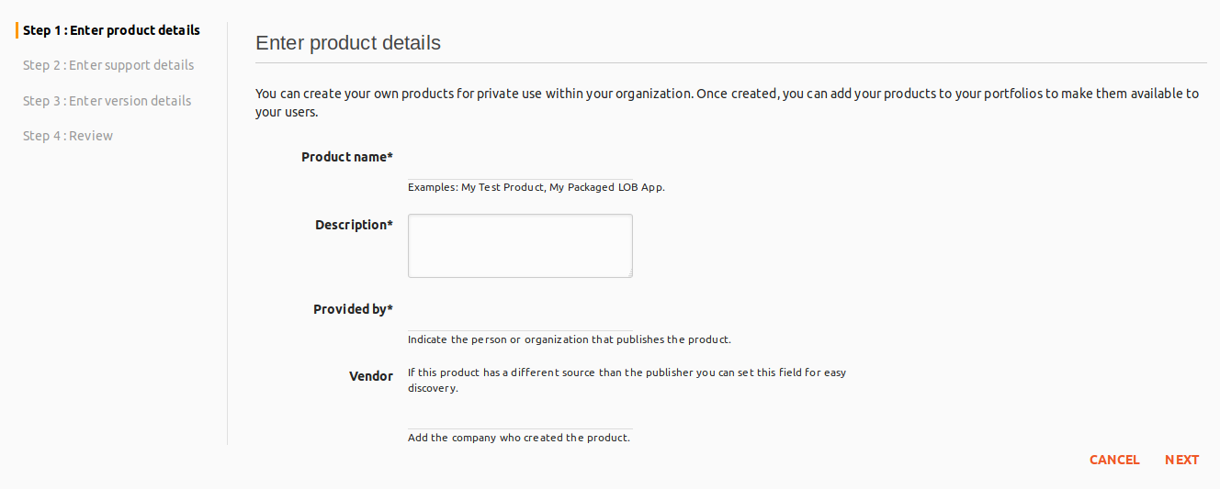
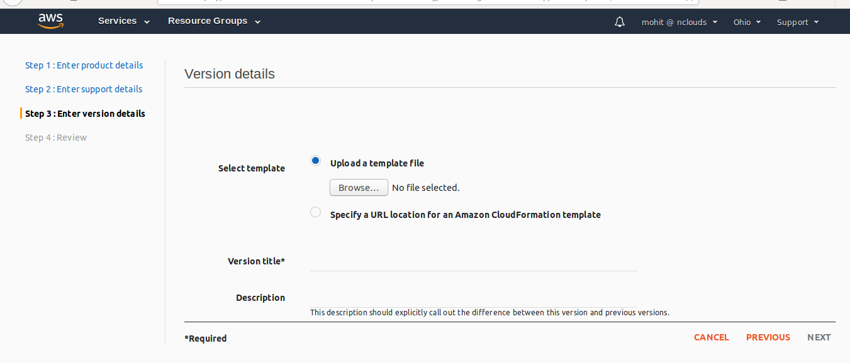
- Grant the policy specific to the new product to the workflow users group or to specific users and add that configuration in the portfolio details page
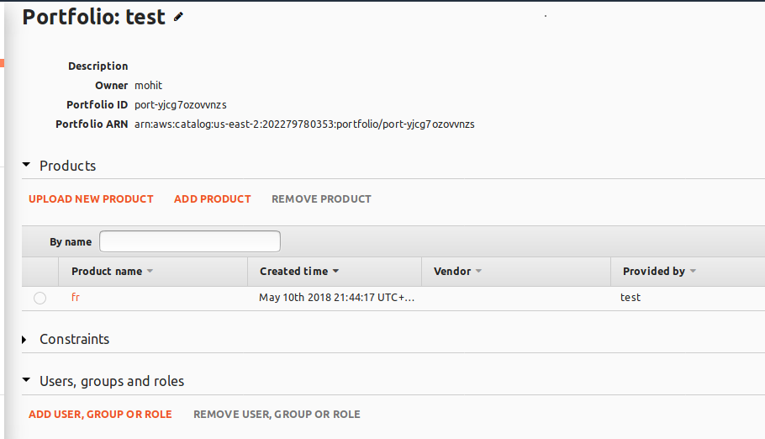

Sharing and importing Portfolios
To share a Portfolio you will need:
- The account Id of the receiving account

On the owner side:
- Go to the details page of the Portfolio you want to share and expand the Share with other AWS accounts section:
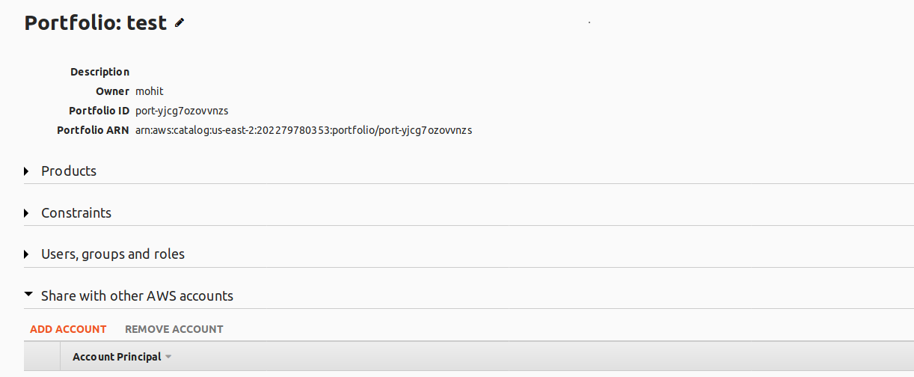

- Click on Add Account and input the receiver account’s Id
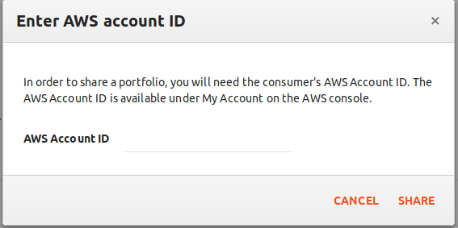
- Take note of the provided link after clicking Share
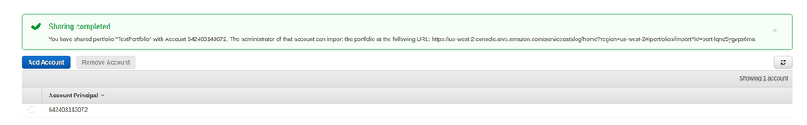
- Send that link to the client

On the client’s side
- Login into the AWS console
- Click on the link provided by nOps administrator
- Click on Import
- Add users and group in the imported Portfolio details page

